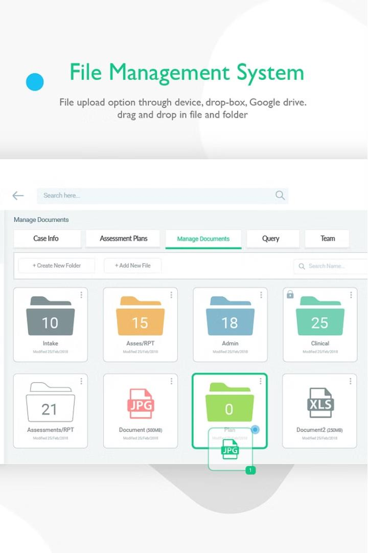









# preencoded.pngCommand-Line Interface (CLI)

**List Files**

**1**

**2**

**3**



**Create File**



**Delete File**



**Command-Line Interface (CLI) Continued**

## Rename File

Users can rename exist ing files on the server, allowing them to better organize and manage their files. If the specified file does not exist, the syst em will notify the user.

## Clear File Content

Users can clear the content of exist ing files on the server, effectively resetting the file to an empty st ate. If the specified file does not exist, the syst em will notify

the user.

## Write to File

Users can write data to exist ing files on the server, enabling them to update and maintain the content of their files. If the specified file does not exist , the syst em will inform the user.

**1**

**2**

**3**

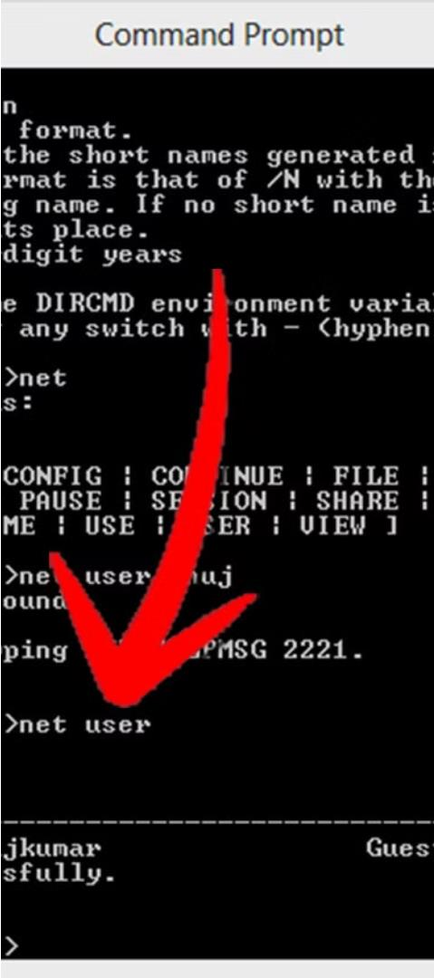

# Command-Line Interface (CLI) Continued

**Read File**

**1**

**2**



**Exit**





# Graphical User Interface (GUI)

**List Files**

The GUI provides a scrollable text box that displays the list of files available on the server, allowing users to easily view and manage the

contents of the file system.

**Create File**

Users can input a filename in a text box and click a button to create a new file on the server. If the file already exists, the system will notify the user.

**Delete File**

Users can select a file from the list and click a button to delete the file from the server. If the specified file does not exist, the system will inform the user.

# Graphical User Interface (GUI) Continued

**Rename File**

Users can input the old and new filenames in text

and click a button to rename the file on the server. If the specified file does not exist, the system will notify the user.

**Write to File**

Users can input a filename and data in text boxes, then click a button to write the data to the corresponding file on the server. If the specified file does not exist, the system will inform the user.

**Read File**

Users can input a filename in a text box and click a button to display the

content of the file in a scrollable text box. If the file is empty or the specified file does not exist, the system will notify the user.







# Error Handling and Future Enhancements

**Error Handling Future Enhancements**

**1**

**2**









**AMAR VARPE - ITTE57**

**OMKAR SHELKE - ITTE58**

**VAIBHAV VAVHAL - ITTE59**

**THANK YOU**